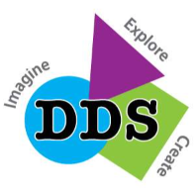
In recognition of National Indigenous Peoples Day,
and in alignment with the CBE Education Plan,
Douglasdale School
acknowledges and supports the Truth and Reconciliation Commission of Canada’s (TRC) Calls to Action, and makes the following commitment to action for the 2026-2027 school year:

Spirit - To Be: Create opportunities for students, staff, and families to build and nurture learning relationships with Indigenous Elders and Knowledge Keepers that fosters a spirit of reciprocity.
Date: September 29, 2026

